Tyndale recommends using Google Chrome for the best online experience.
Below is a step by step guide to order your PPE items, boots / shoes included!
Tyndale Website Address: www.TyndaleUSA.com

Enter your User Name and Password, then select Log In
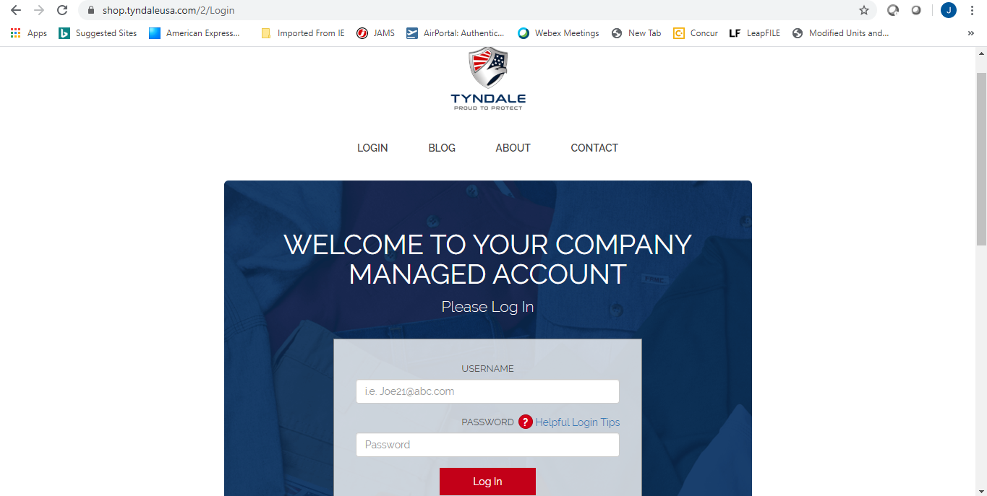

Please read and acknowledge the Landing page by selecting Continue
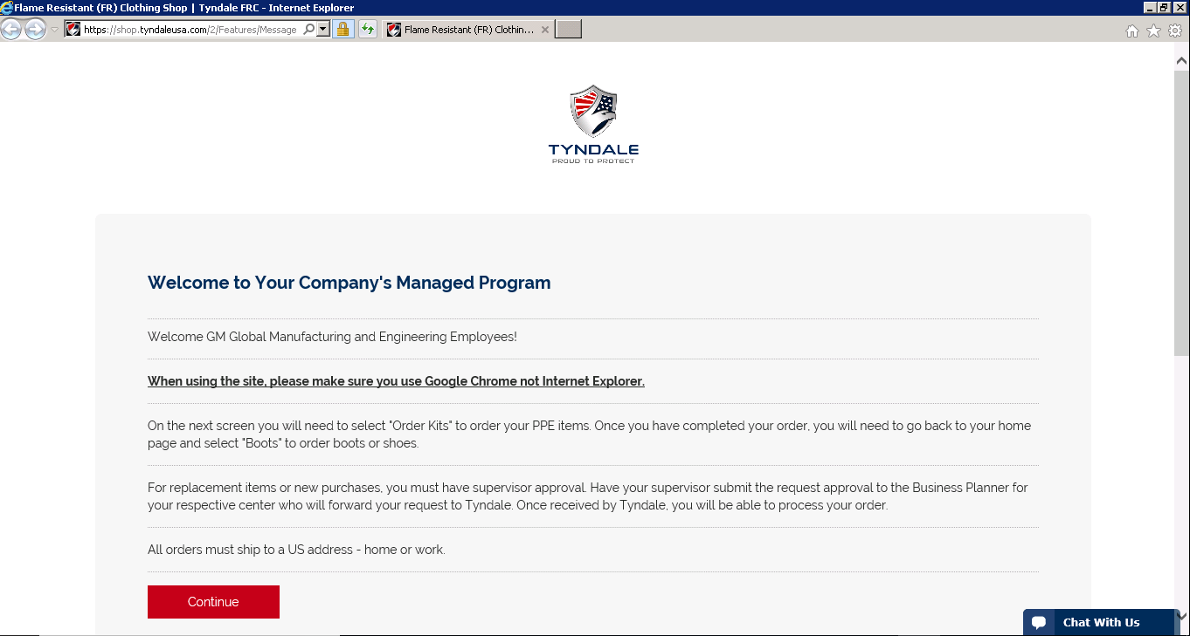
**At any time during the order process, should you have any questions you can chat with one of our Customer Service Reps. They are available Monday through Friday 8am-7pm eastern time via chat and phone.**

To order your PPE items, select “ORDER KITS”.
DO NOT USE REGULAR KIT
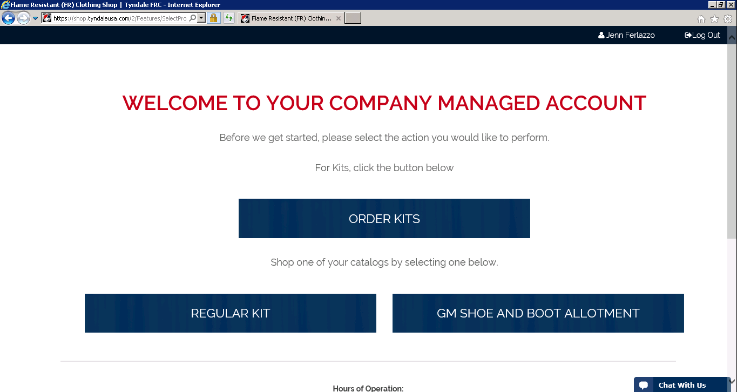

Select “GM Regular Kit”
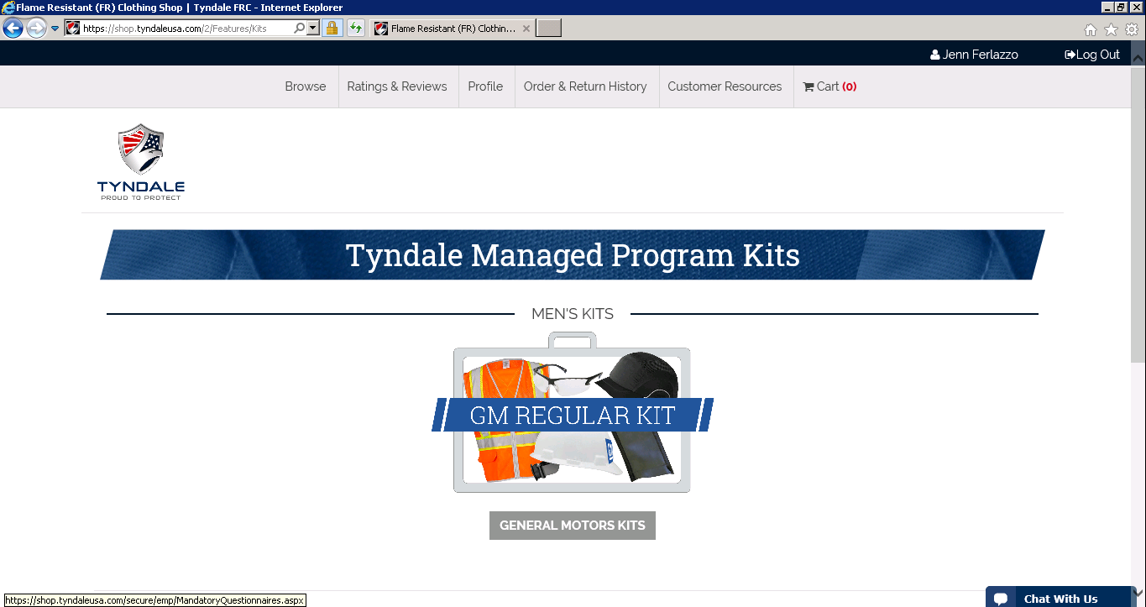

The items that do not require a size (one size fits all) will automatically populate in your cart
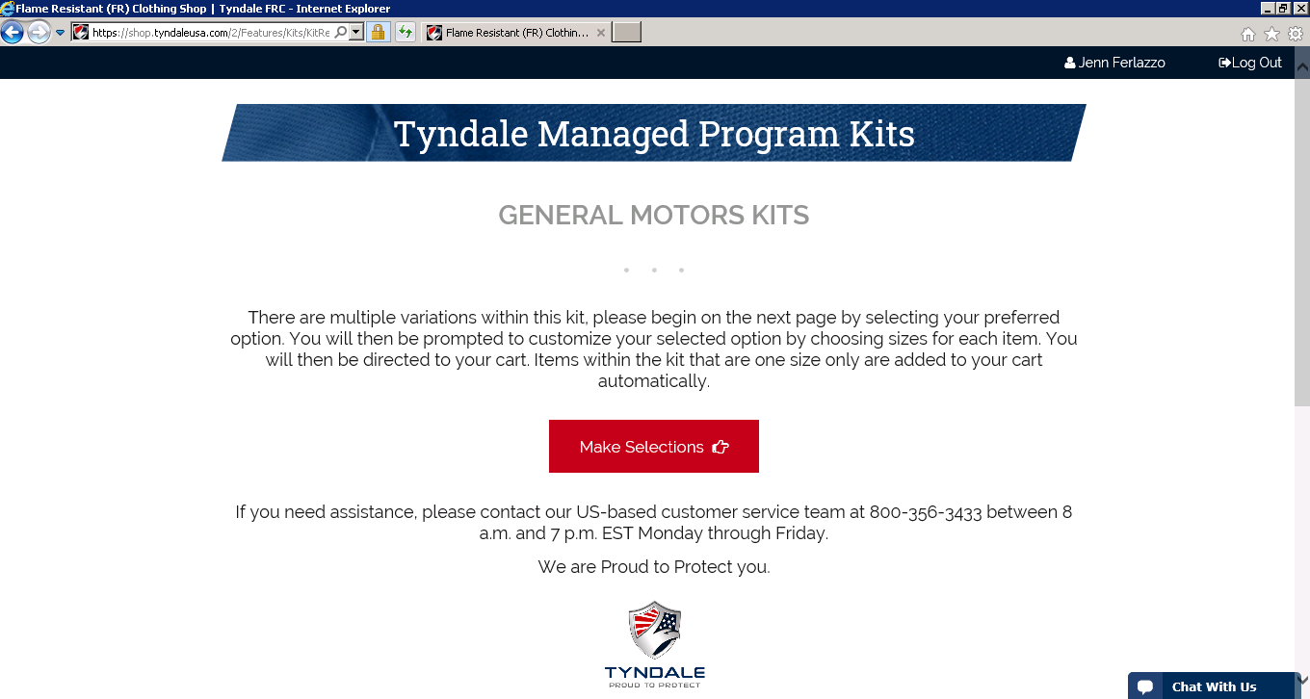

Once you have arrived at the Tyndale Managed Program Kits – this is where you will select which kit you want to order. It’s very important to note that there are 20 different kit options / combinations. The different options / combinations are listed above each grouping of picutres.
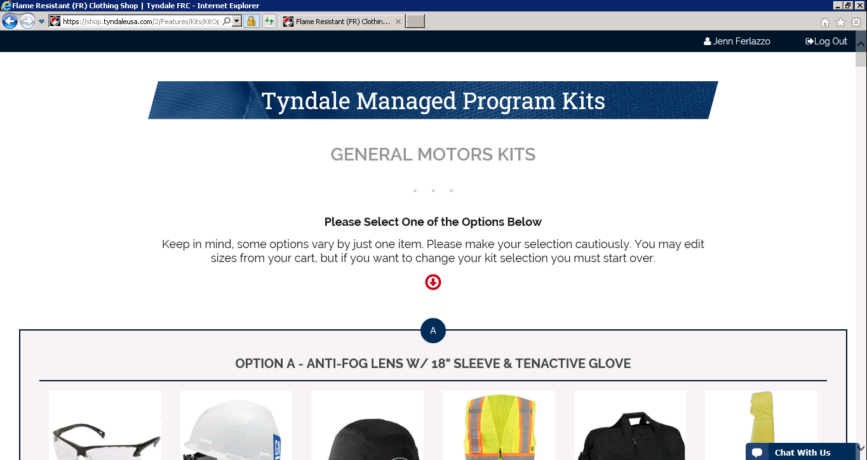

Once you have found the kit you wish to order, press Select Option as pictured below
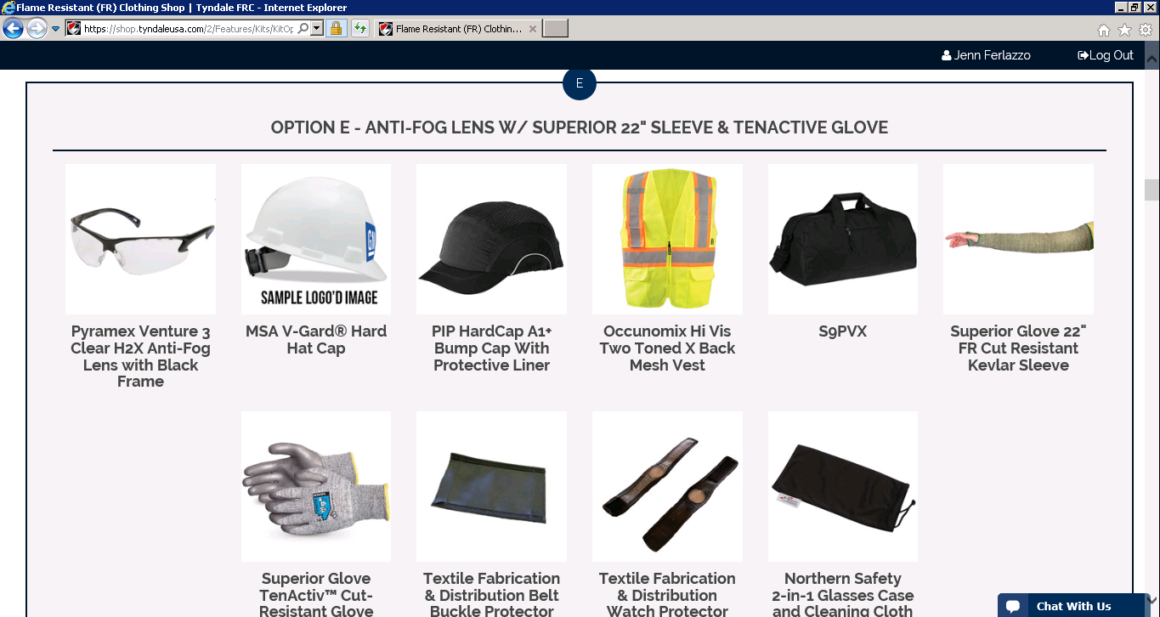

Choose your size of the Vest
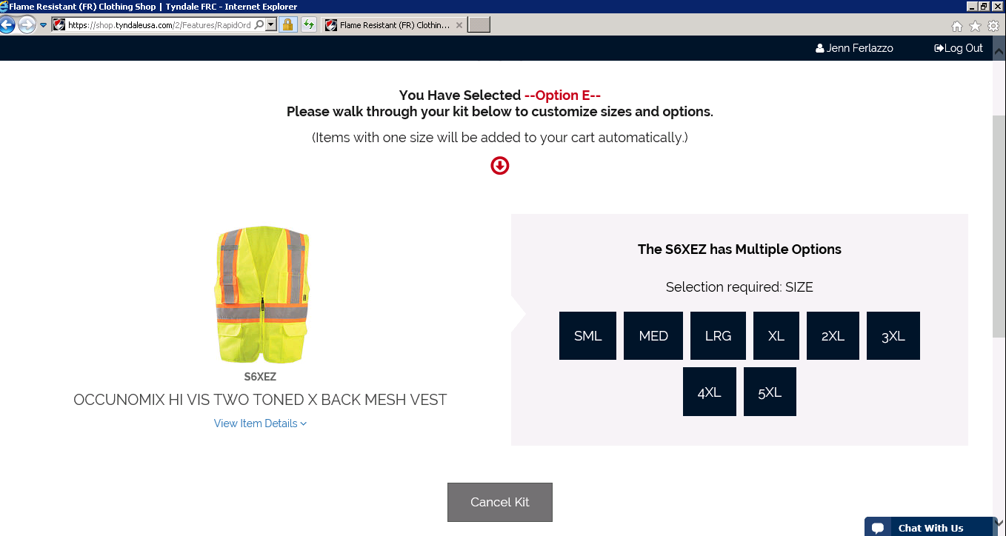

Choose your size for the Safety Sleeve
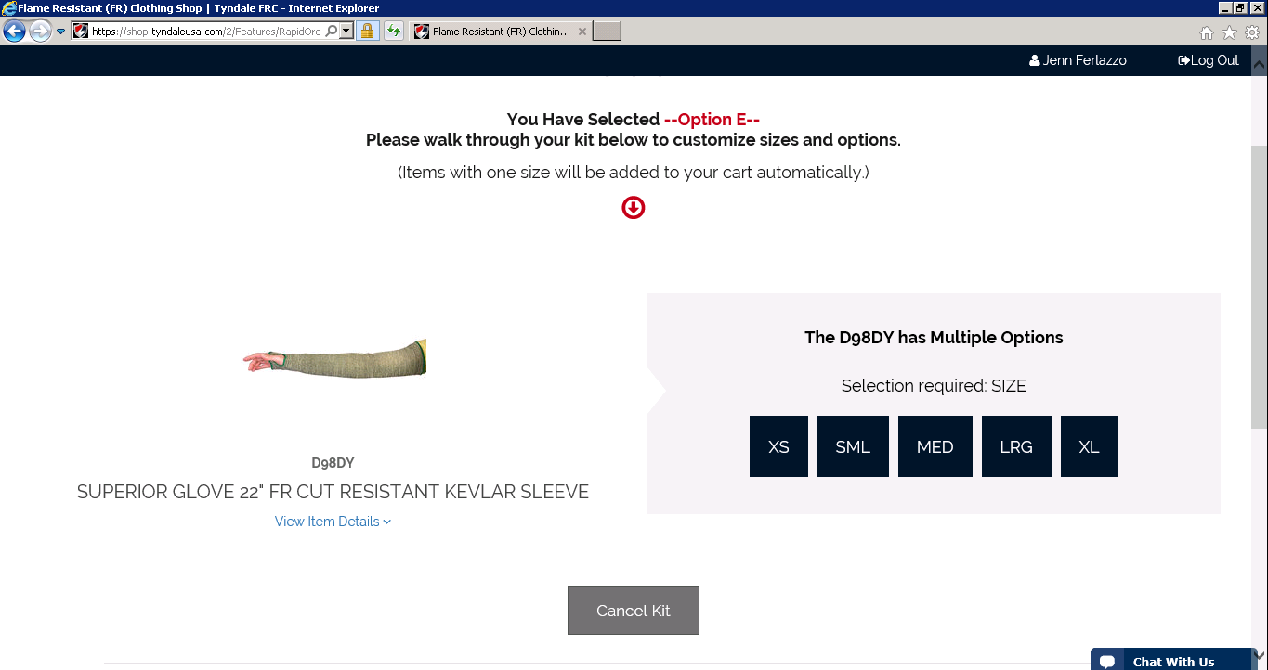
Choose your size for the glove. If you are unsure of your glove size, you can use download a sizing chart. Also, a little tip…..your hand size is normally close to your shoe size.
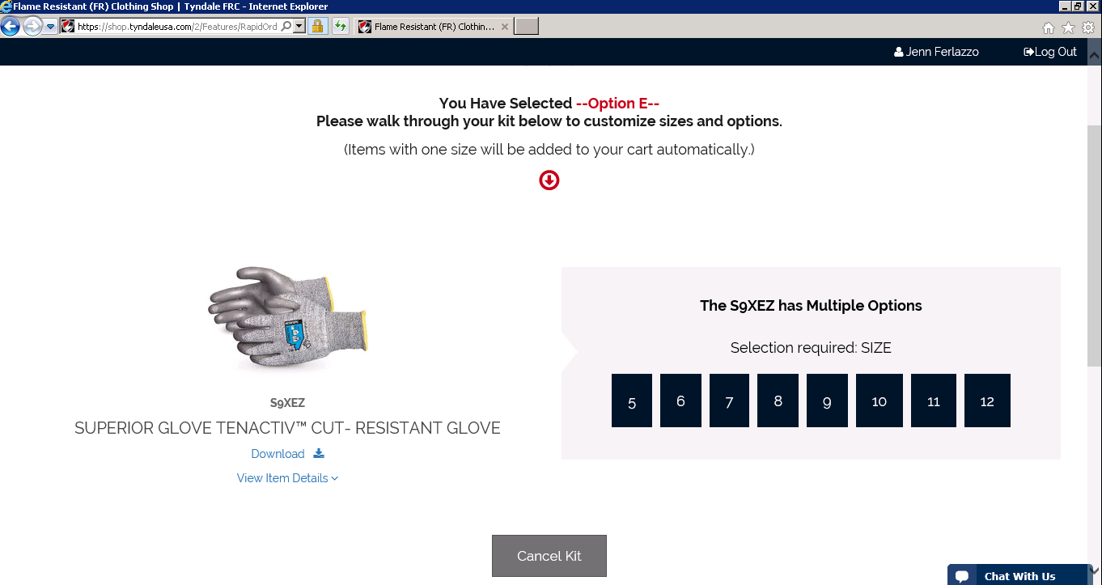

Below is a screen shot of your cart, scroll through the page to review your items. Once you have reviewed select Check Out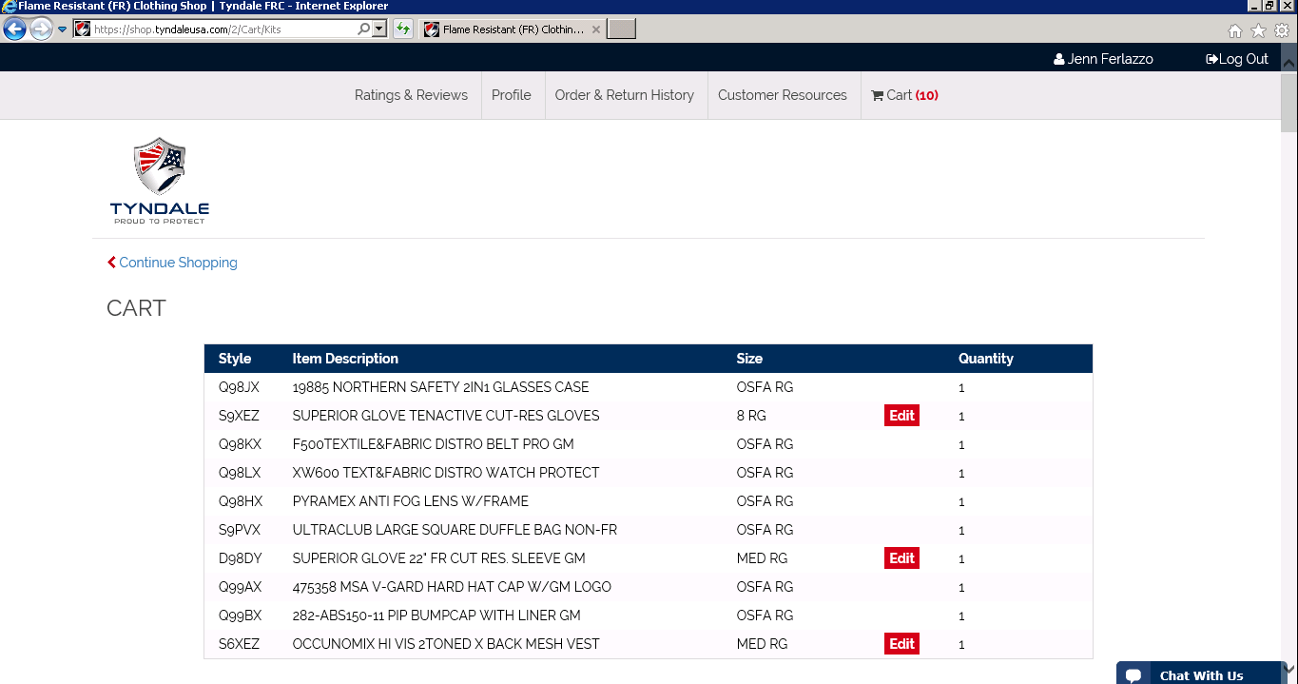
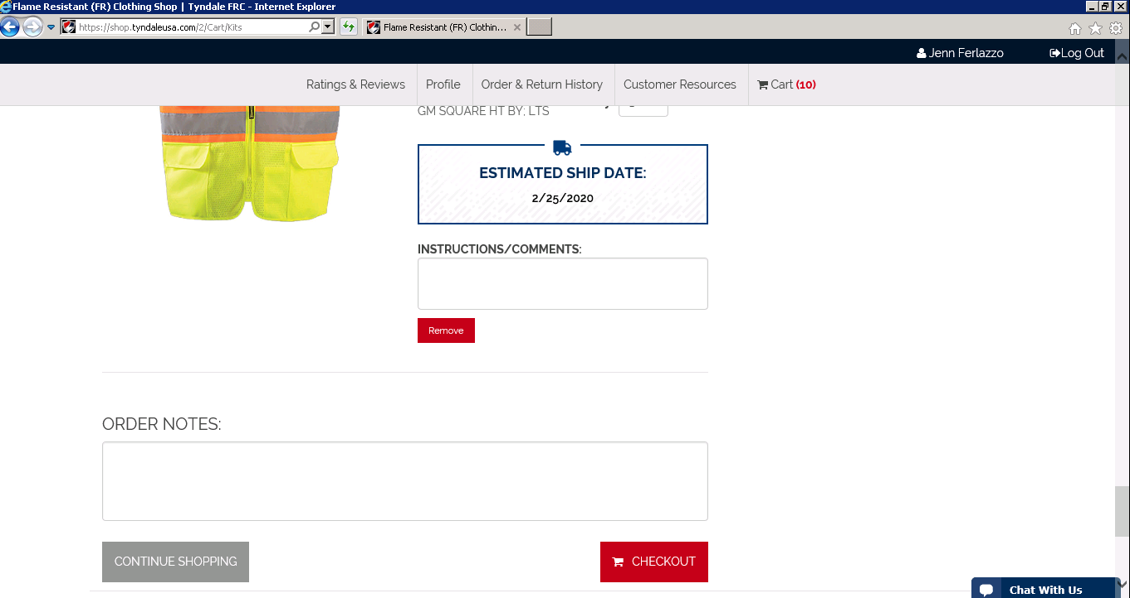

Enter your shipping address, then select Continue
**Only shipments to a US address are permitted**
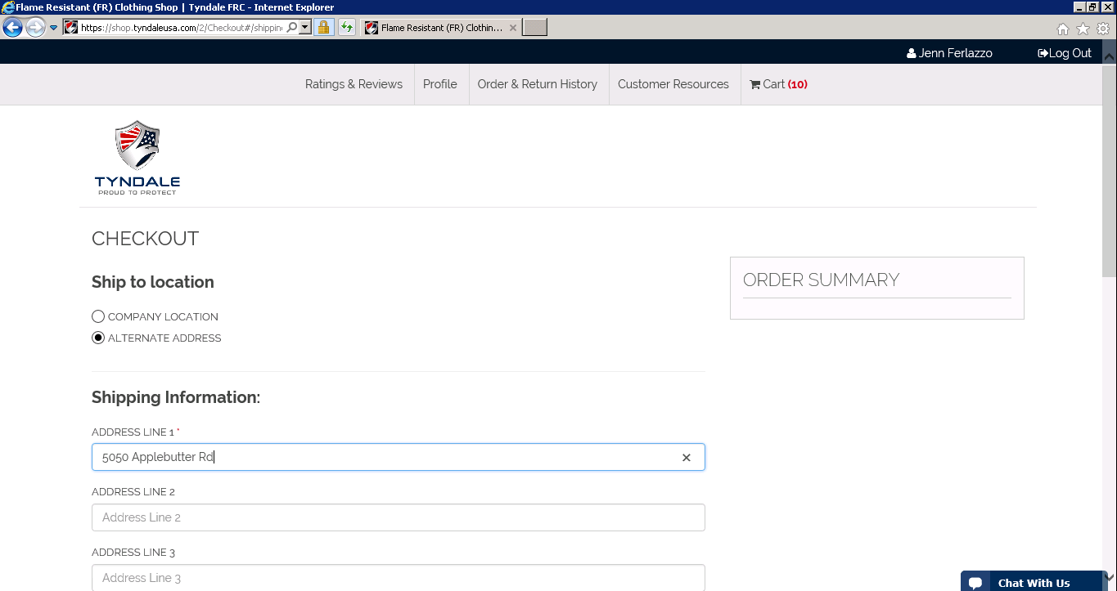
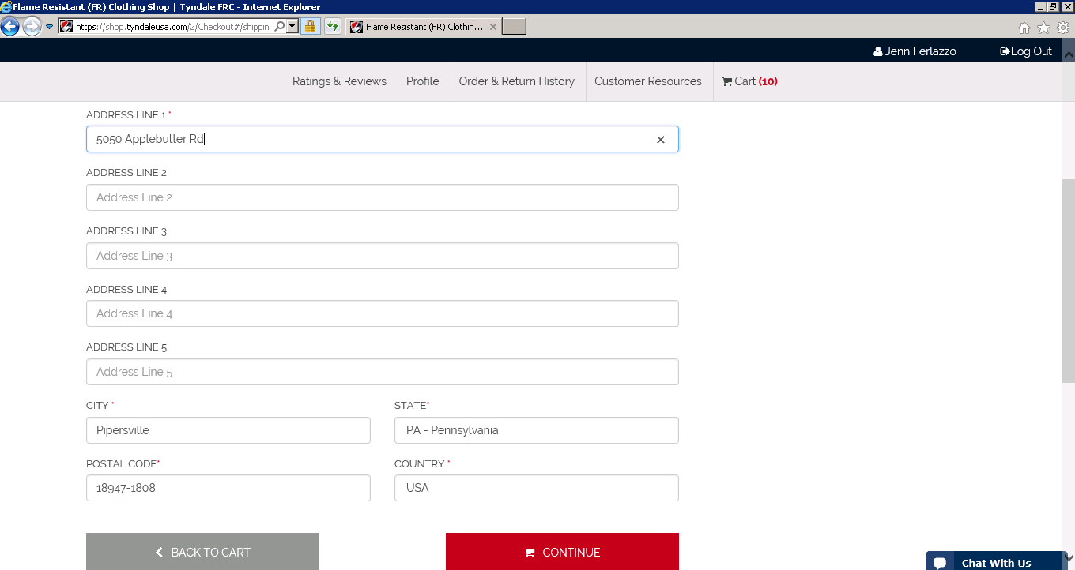

Scroll through the checkout page to review your order and shipping address, then Submit your order.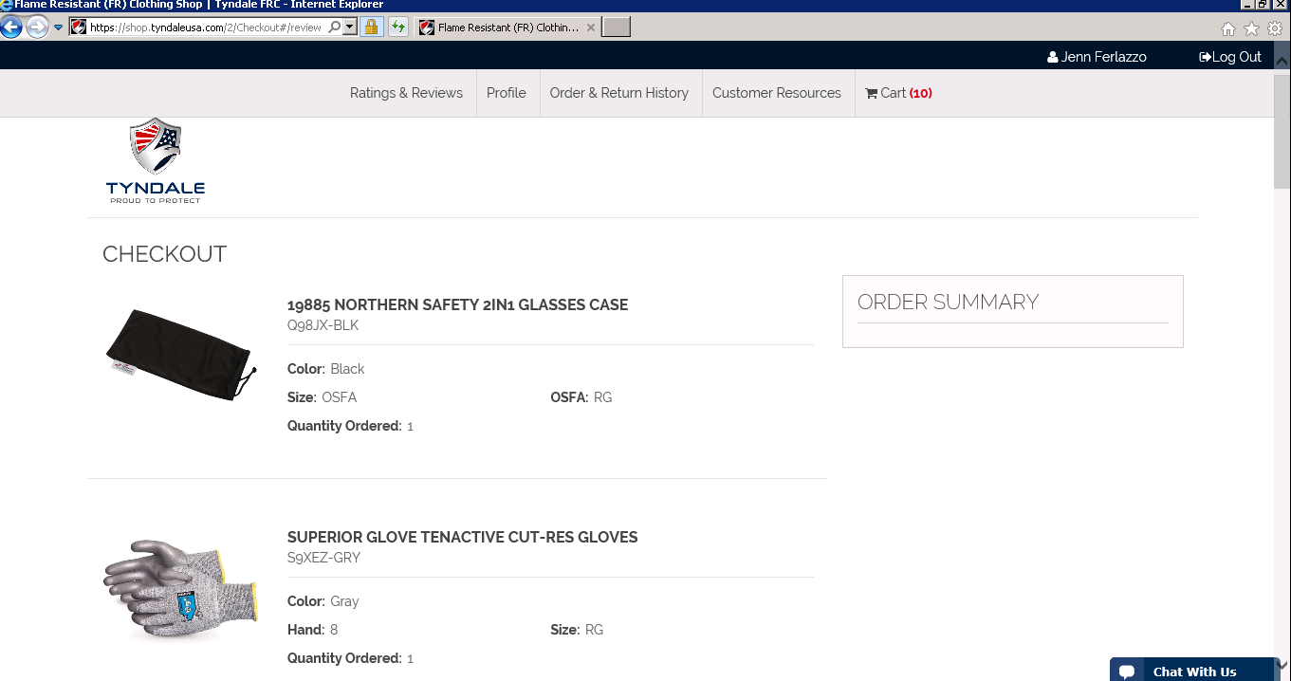

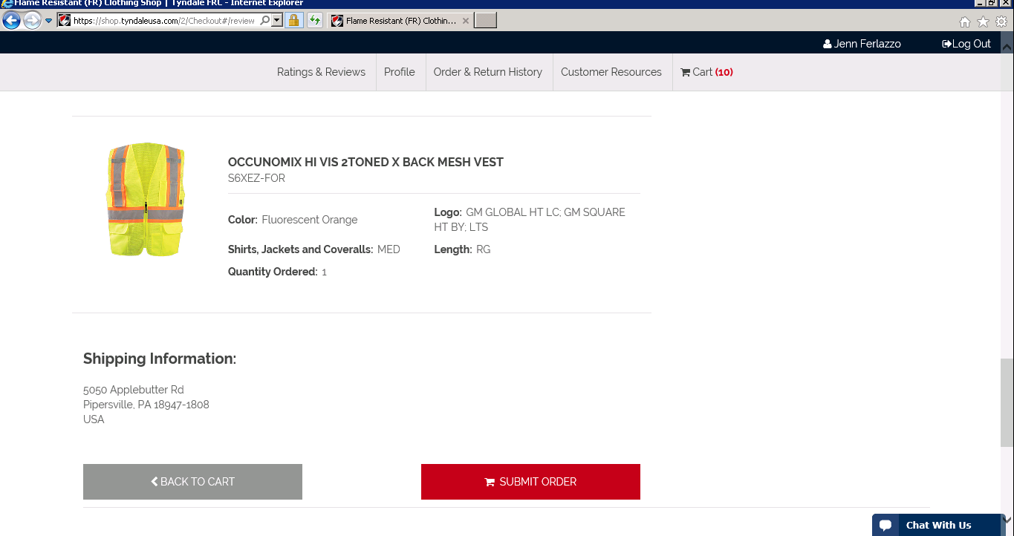

Below is your order confirmation, you will also receive an order confirmation email.
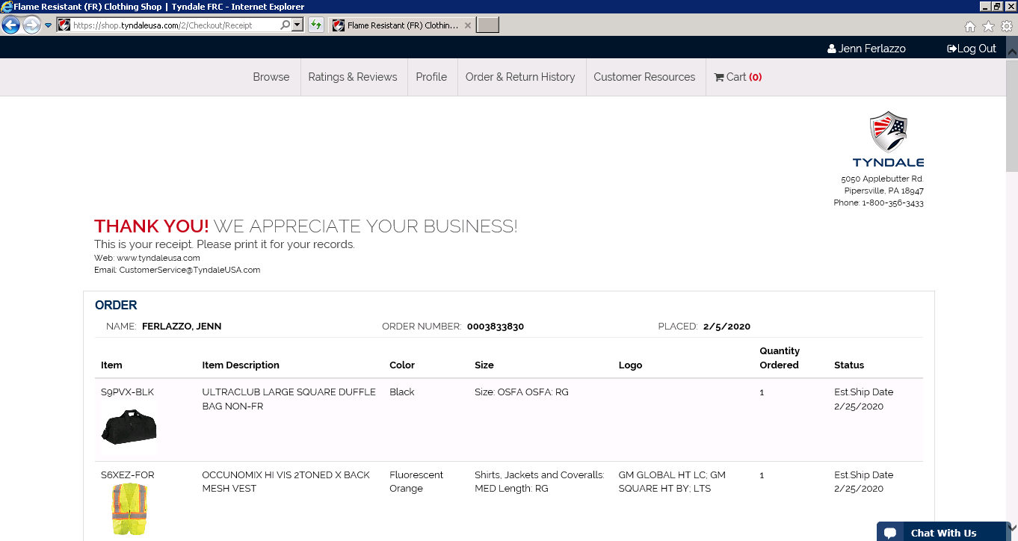

Next, let’s order your Boots or Shoes. You are only permitted one boot or shoe.
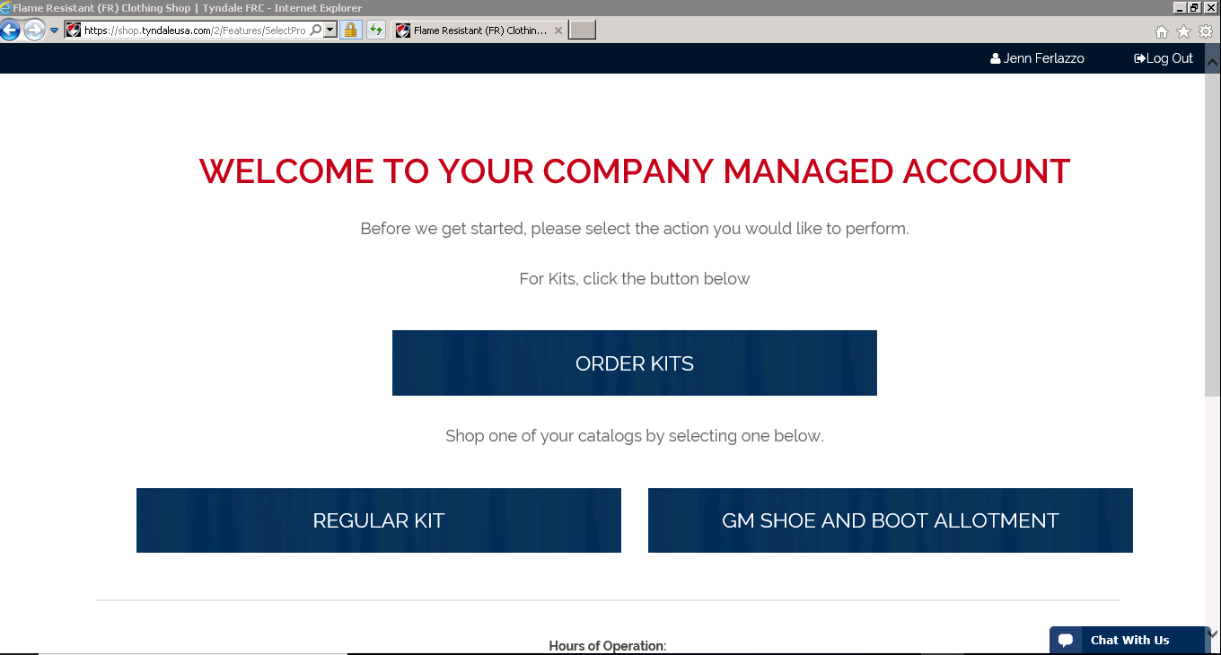

Select Shop Catalog
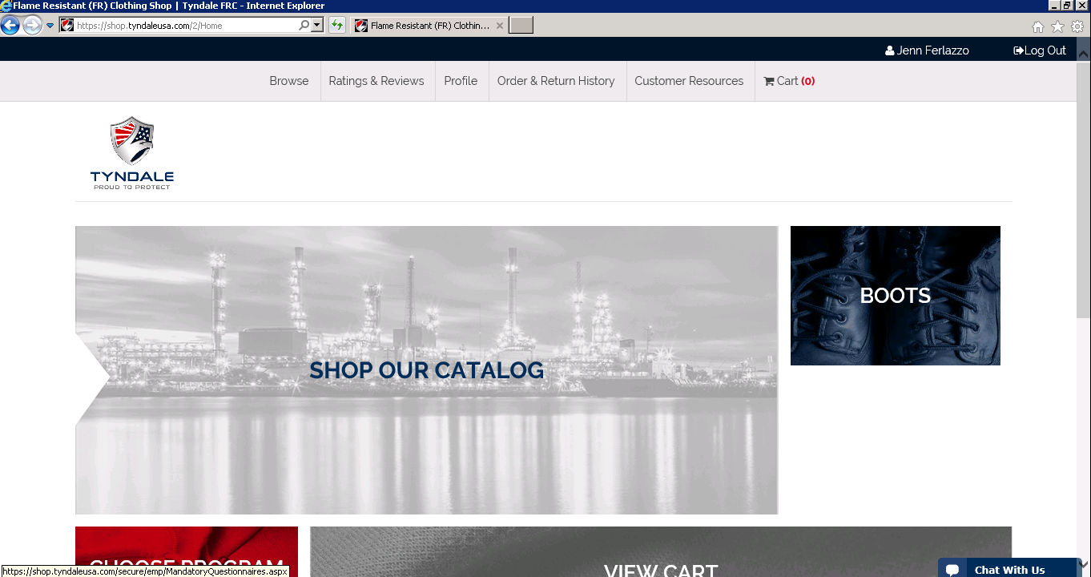

Choose the Boot or Shoe you wish to purchase
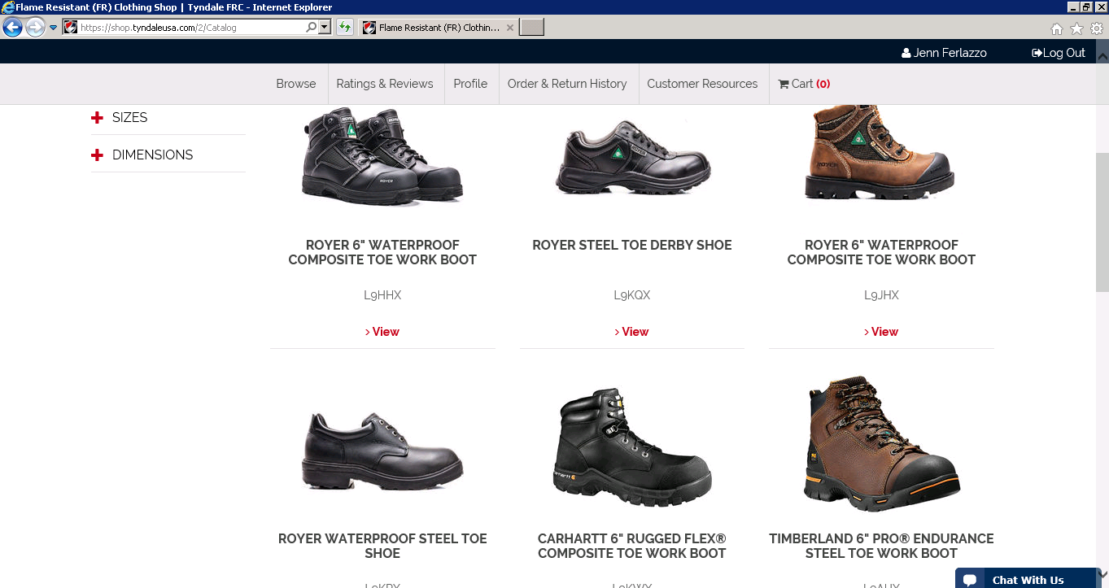

Next you will see a close up picture of the boot / shoe, item description. You will want to select your size, and width (if applicable). Once you have selected your size and width you will be provided with an estimated order ship date.
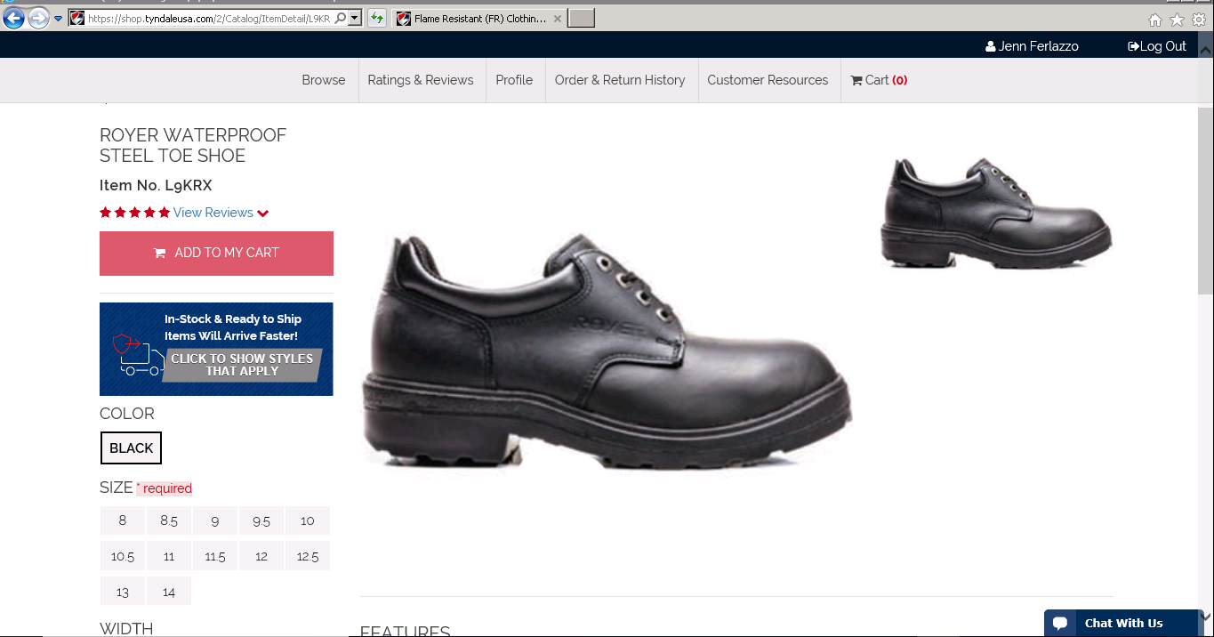
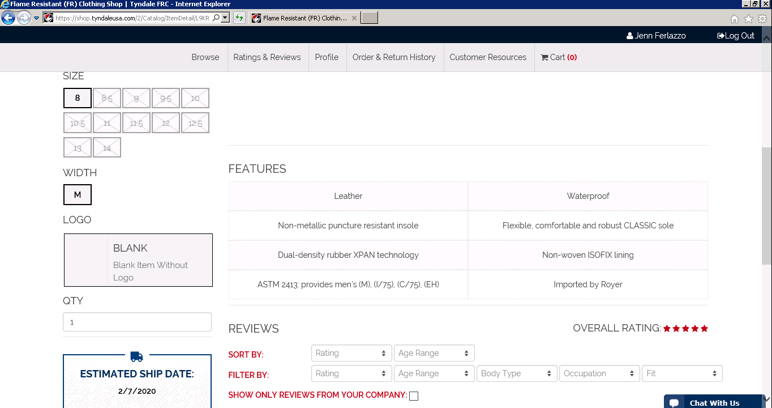

Select Add to My Cart
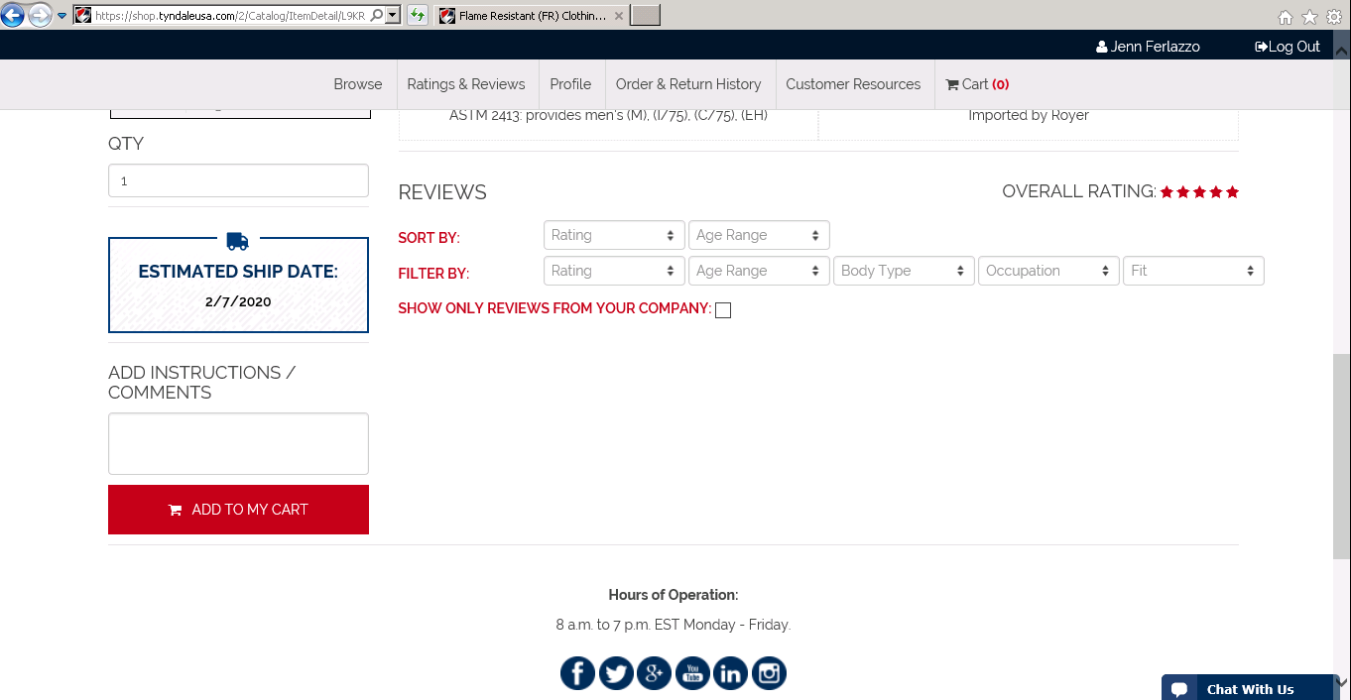

Review your cart
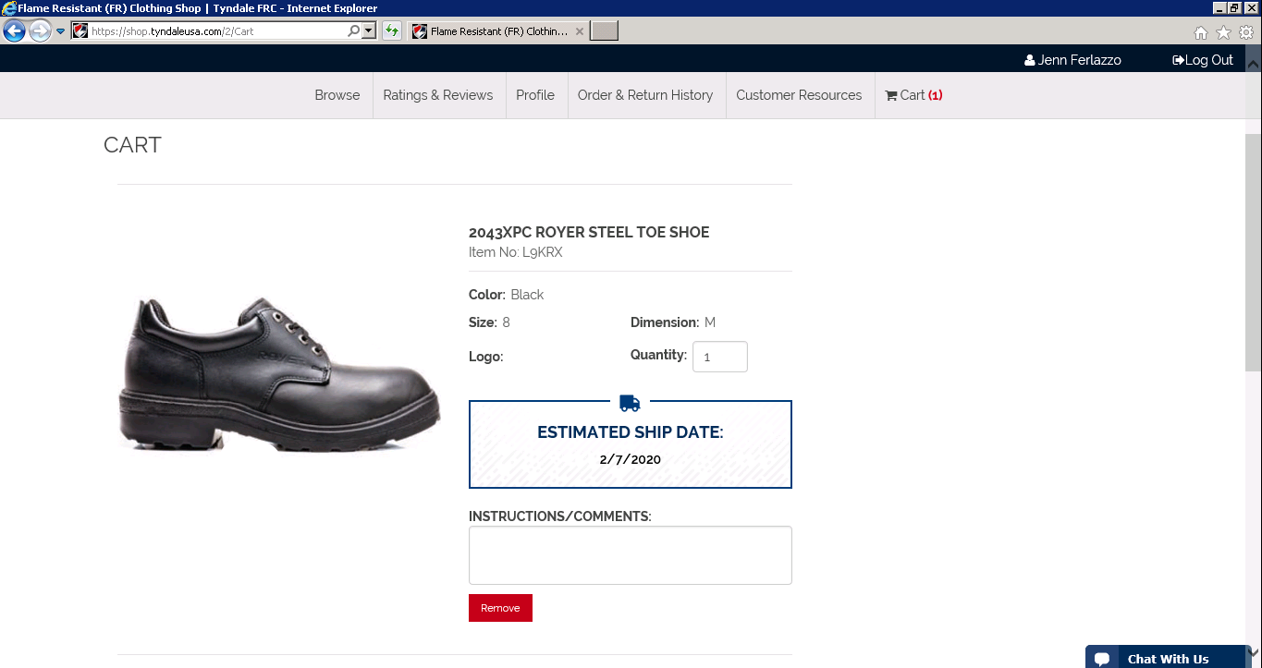

Select Checkout
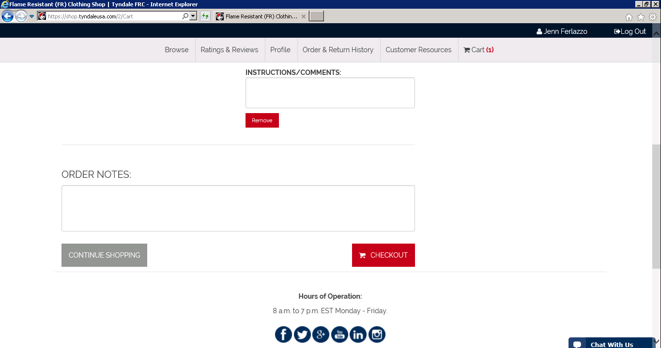

Enter your shipping address and select Continue
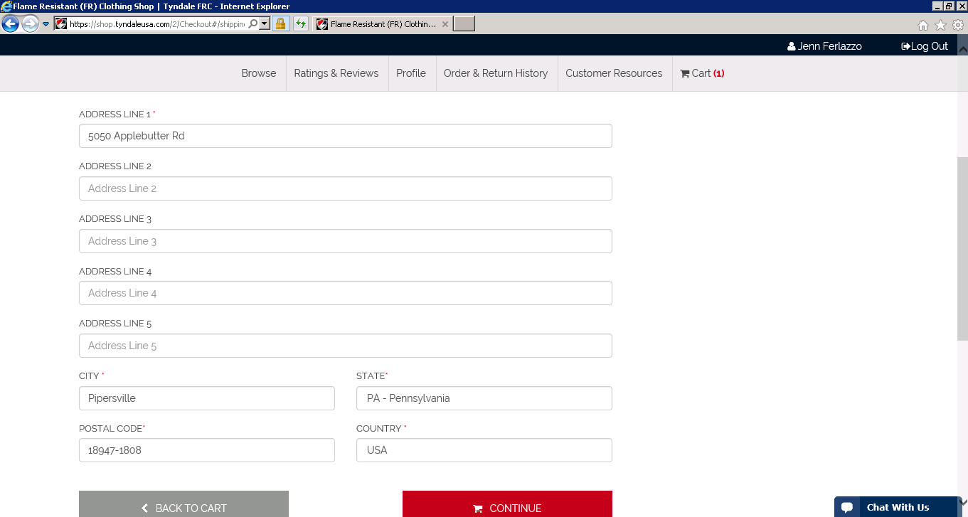

Review your order and shipping address one last time, select submit order.
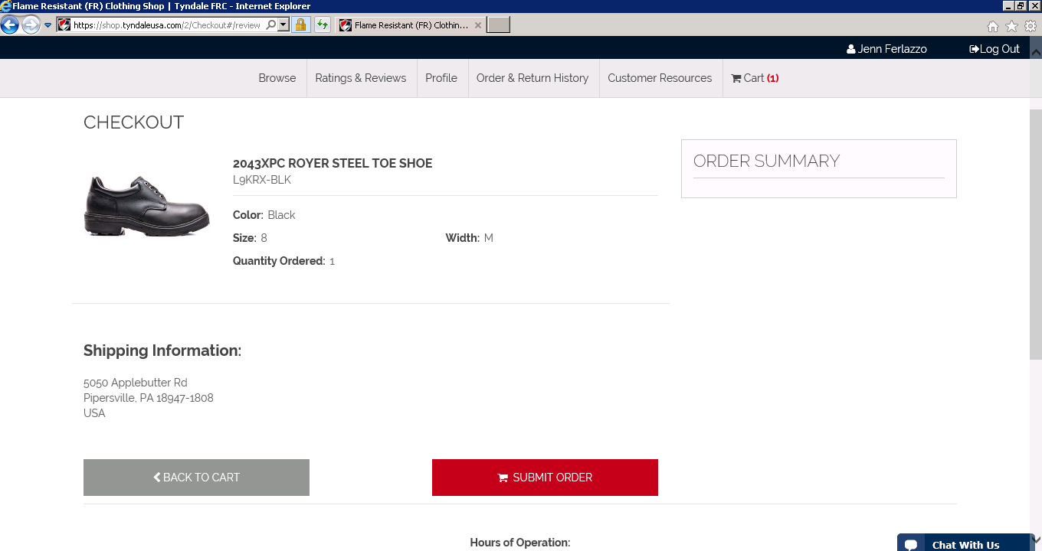
You will receive an order confirmation and an order confirmation email
